Jadavpur University

Department of Electronics and Telecommunication Engineering,

Faculty of Engineering & Technology

DSA LAB REPORT

2nd Year First Semester 2020



Name : RAHUL SAHA

Roll: 001910701009

Group 1

IMPLEMENTATION OF CIRCULAR QUEUE AND PRIORITY QUEUE

Date Of Submission: 22/04/2021

Assignments - 05

1. Implement a circular queue. Demonstrate that problems appearing in a linear queue can be circumvented in a circular queue.
2. Implement a min-priority queue. Your program should contain all the necessary functions like extract_min() and others.
3. **Circular Queue**

Source Code:

|  |
| --- |
| **#include<stdio.h> #include<conio.h> #include<stdlib.h> #define MAX 5  int cqueue[MAX];*//INITIALIZING THE QUEUE* int rear=-1; int front=-1;  *//FUNCTION TO DISPLAY THE QUEUE* void queue_display(){  int i;  printf("\n\nDisplaying the elements of the queue...\n\n");  if(front==-1){  printf("\n\nThe queue is Empty");  getch();  return;  }  else{  for(i=front;i!=rear;i=(i+1)%MAX)**  **{**  ***//ITERATION UNTIL i IS EQUAL TO REAR*  printf("%d ",cqueue[i]);**  ***//PRINTS THE ELEMENT AT POSITION i OF THE ARRAY*  }  printf("%d ",cqueue[i]);*//PRINTS THE REAR ELEMENT*  }  getch(); }  *//FUNCTION TO INSERT AN ELEMENT INTO THE QUEUE* void enqueue(){  system("cls");  printf("\t\tCircular Queue: Insert Operation");  if((front==0 && rear==MAX-1)||(front==rear+1)){  printf("\n\nThe Queue is overflow");  getch();  return;  }  else{  if(front==-1){  front=0;  }  rear=(rear+1)%MAX;*//IF END OF ARRAY IS REACHED THEN ELEMENT WILL BE INSERTED IN THE ARRAY BEGINNING PROVIDED THERE IS SPACE HENCE CIRCULAR*  printf("\n\nEnter the Data:");  scanf("%d",&cqueue[rear]);  }  queue_display();  return; }  *//DELETING AN ELEMENT FROM QUEUE* void dequeue(){  system("cls");  printf("\t\tCircular Queue: Deletion Operation");  if(front==-1){  printf("\n\nThe queue is Underflow");  getch();  return;  }  printf("\n\nThe deleted element from the Queue is: %d",cqueue[front]); *//DELETING THE FRONT ELEMENT*  if(front==rear)**  **{ *//IF ONLY ONE ELEMENT IS PRESENT RESETTING THE QUEUE*  front=-1;  rear=-1;  }  else{  front=(front+1)%MAX;   }  queue_display();  return; }  *//DISPLAYS THE FRONT ELEMENT OF THE QUEUE* void queue_front()**  **{  system("cls");  printf("\t\tCircular Queue: Displaying the front element of the Queue ");  if(front==-1){  printf("\n\nThe queue is underflow");  }  else{  printf("\n\nThe front element is: %d",cqueue[front]);**  ***//PRINTS THE FRONT ELEMENT*  }  getch();  return; }  *//DISPLAYS THE SIZE OF THE QUEUE* void queue_size(){  system("cls");  int i,count=0;  printf("\t\tCircular Queue: Displaying the size of the Queue");  if(front==-1){  printf("\n\nThe size of the Queue is: 0");  }  else**  **{  for(i=front;i!=rear;i=(i+1)%MAX)**  **{  Count++; *//INCREMENT OF THE COUNT BY 1*   }  printf("\n\nThe size of the Queue is: %d",count+1);**  ***//PRINTS THE NUMBER OF ELEMENTS IN THE QUEUE*  }  getch();  return; } *//DRIVER FUNCTION WHICH HAS THE SWITCH CASE STRUCTURE* int main(){  int ch;  do{  system("cls");  printf("\t\tImplementation of Circular Queue");  printf("\n\n1.ENQUEUE(inserts an element in the queue)");  printf("\n\n2.DEQUEUE(deletes an element from the queue)");  printf("\n\n3.DISPLAY(displays the queue elements)");  printf("\n\n4.FRONT(displays the front element without deleting it)");  printf("\n\n5.SIZE(displays the size of the queue i.e the number of elements)");  printf("\n\n0.EXIT");  printf("\n\nEnter your choice: ");  scanf("%d",&ch);  switch(ch){  case 1: enqueue();  break;  case 2: dequeue();  break;  case 3: queue_display();  break;  case 4: queue_front();  break;  case 5: queue_size();  break;  case 0: exit(0);    default: printf("Invalid Choice");  break;  }  }while(1); }** |
|  |
|  |

**OUTPUT(s) :**

***Menu template of the user console:***

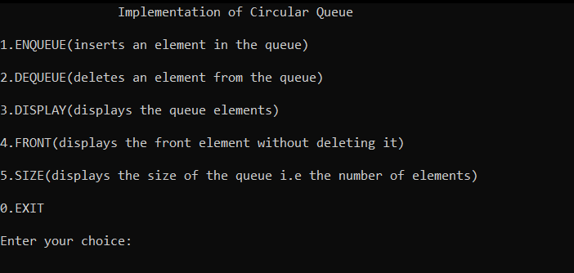

***User creates a circular queue containing elements 1,2,3,4,5 imputed in order.***

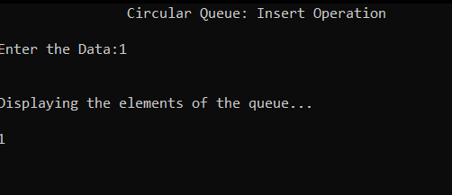

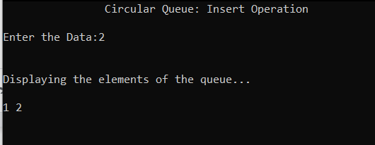

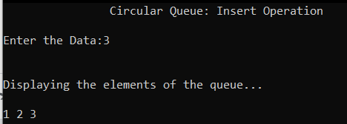

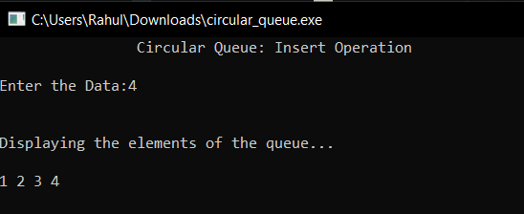

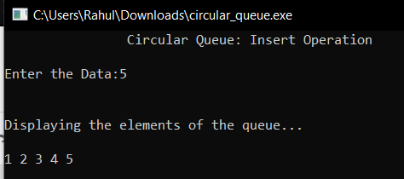

***Deletion ( In FIFO Manner ):***

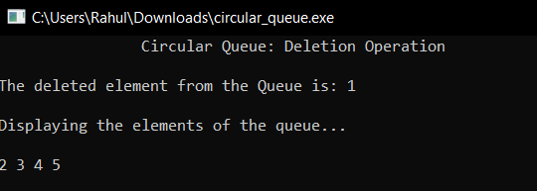

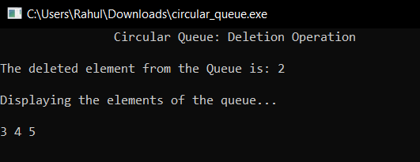

***At any point of the code execution, we can check the size of the queue***

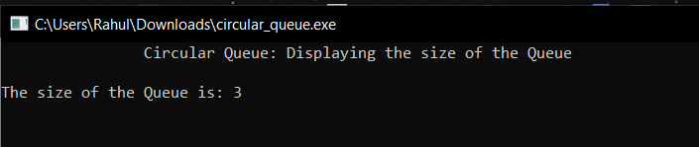

***Let’s say user wants to display the front element of the queue without dequeue the item at the same time***

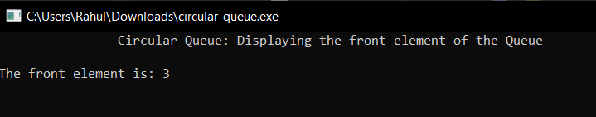

***Displaying the updated queue***

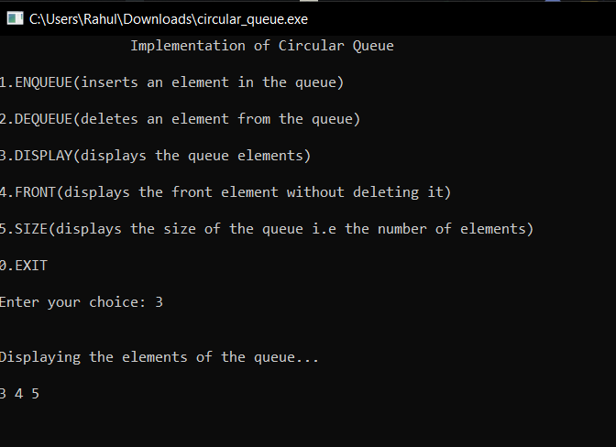

**Overflow Criteria :**

Since the size of the queue was 5 let’s fill the other 2 blank places with two other items

and display the list

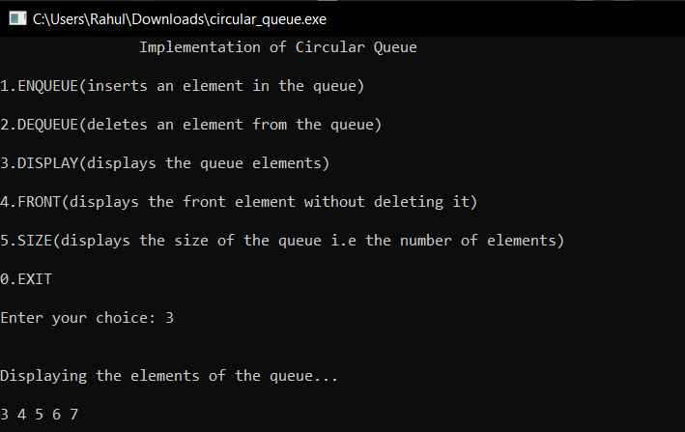

Now if I want to add a new element to the queue, it sends a message as Queue Overflow

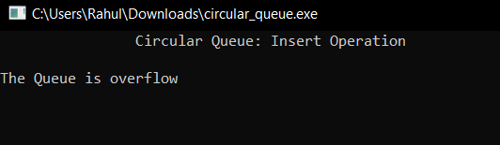

**Underflow Criterion:**

Suppose from the existing list we keep on removing the elements one by one. A point will come when there will be no elements on the list and if we still try to delete the same the queue will undergo through an Underflow Condition

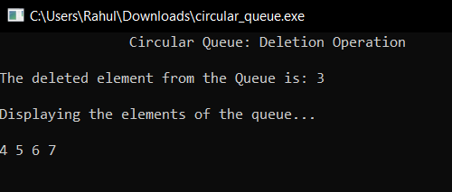

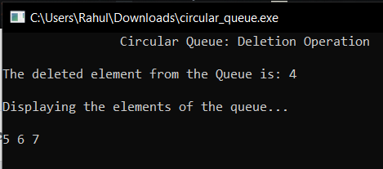

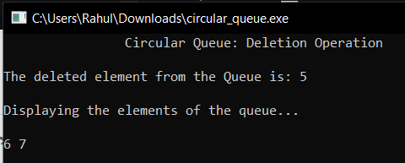

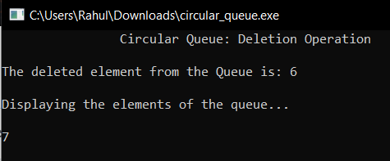

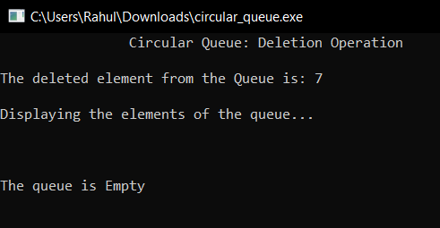

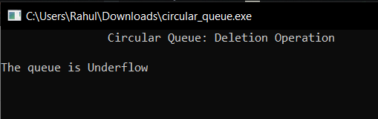

1. **Priority Queue**

Source Code:

|  |
| --- |
| **#include<stdio.h> #include<conio.h> #include<stdlib.h> #define MAX 100  int array[MAX]; int ptr=-1;  *//FUNCTION TO SWAP ELEMENTS* void element_swap(int *elem1,int *elem2){  int temp;  temp=*elem1;  *elem1=*elem2;  *elem2=temp; }  *//FUNCTION TO FIND THE SIZE OF THE QUEUE* int size(){  int i,count=0;  if(ptr==-1){  return 0;  }  for(i=0;i<=ptr;i++){  count++;  }  return count; }  *//FUNCTION TO DISPLAY THE PRIORITY QUEUE* void display(){  int i;  if(ptr==-1){  printf("The queue is empty");  getch();  return;  }  for(i=0;i<=ptr;i++){  printf("%d ",array[i]);  }  getch();  return; }  *//FUNCTION WHICH RETURNS THE INDEX OF THE PARENT NODE OF A GIVEN NODE* int parent(int index){  return (index-1)/2; }  *//FUNCTION WHICH WHICH RETURNS THE INDEX OF THE RIGHT CHILD OF A GIVEN NODE* int right_child(int index){  return(2*index+2);  }  *//FUNCTION WHICH WHICH RETURNS THE INDEX OF THE LEFT CHILD OF A GIVEN NODE* int left_child(int index){  return(2*index+1); }  *//FUNCTION TO RETURN THE MINIMUM PRIORITY ELEMENT* int get_min(){  return array[0]; }  *//FUNCTION TO SHIFT UP THE DOWN THE NODE MAINTAIN THE HEAP PROPERTY* void heap_minimum(int index){  int index_left_child, index_right_child,minimum;  index_left_child=left_child(index);  index_right_child=right_child(index);   minimum=index;  if(index_left_child<=ptr and array[index_left_child]<array[minimum]){  minimum=index_left_child;  }   if(index_right_child<=ptr and array[index_right_child]<array[minimum]){   minimum=index_right_child;  }   if(minimum!=index){   element_swap(&array[index],&array[minimum]);  heap_minimum(minimum);   } }  *//FUNCTION TO SHIFT UP THE NODE TO MAINTAIN HEAP PROPERTY* void decrease_val(int index){  while((index>0) && (array[parent(index)]>array[index])){  element_swap(&array[index],&array[parent(index)]);  index=parent(index);  } }  *//INSERTS A NEW ELEMENT TO THE BINARY HEAP* void insert(int element){  ptr=ptr+1;  array[ptr]=element;  decrease_val(ptr); }  *//FUNCTION TO CREATE A PRIORITY QUEUE* void create(){  system("cls");  printf("\t\tCreating a Priority Queue");  int number_of_elements,i;  printf("\n\nEnter the number of elements to be inserted: ");  scanf("%d",&number_of_elements);  for(i=0;i<number_of_elements;i++){  int element;  printf("\n\nEnter the data:");  scanf("%d",&element);  insert(element);  printf("\nThe priority Queue is...\n");  display();  } }  *//FUNCTION TO INSERT AN ELEMENT IN THE PRIORITY QUEUE* void op_insert(){  system("cls");  printf("\t\tInsertion in Priority Queue");  int element;  printf("\n\nEnter the Element:");  scanf("%d",&element);  insert(element);  printf("\nThe priority Queue is...\n");  display(); }  *//FUNCTION TO EXTRACT THE MINIMUM PRIORITY ELEMENT* void extract_min(){  system("cls");  printf("\t\tExtract The minimum element in the priority Queue");  if(ptr==-1){  printf("\n\nThe priority Queue is empty");  getch();  return;  }  printf("\n\nPriority Queue before Extracting Minimum...\n");  display();  printf("\n\nThe minimum element in the priority Queue: %d",array[0]);  array[0]=array[ptr];  ptr--;  heap_minimum(0);  printf("\n\nPriority Queue after Extracting Minimum...\n");  display(); }  *//FUNCTION TO CHANGE PRIORITY OF AN ELEMENT* void change_priority(){  system("cls");  printf("\t\t Changing Priority of Element in the Priority Queue");  int new_priority,position,old_priority;  printf("\n\nEnter the new priority: ");  scanf("%d",&new_priority);  printf("\n\nEnter the index: ");  scanf("%d",&position);  if(position>size()-1){  printf("\n\nInvalid index");  getch();  return;  }  printf("\n\nThe Queue before change in priority..\n");  display();  old_priority=array[position];  array[position]=new_priority;  if(new_priority>old_priority){  heap_minimum(position);  }  else{  decrease_val(position);  }  printf("\n\nThe Queue after change in priority\n");  display(); }  *//FUNCTION TO REMOVE AN ELEMENT FROM A GIVEN INDEX IN THE PRIORITY QUEUE* void remove_index(){  system("cls");  printf("\t\t Remove Element from a given index in the Priority Queue");  int position;  printf("\n\nEnter the Index: ");  scanf("%d",&position);  if(position>size()-1){  printf("\n\nInvalid index");  getch();  return;  }  printf("The Element at index %d is: %d",position,array[position]);  printf("\n\nPriority Queue before Removing the element from Index...\n");  display();  array[position]=get_min()-2;  decrease_val(position);  array[0]=array[ptr];  ptr--;  heap_minimum(0);  printf("\n\nPriority Queue after Removing the element from Index...\n");  display(); }  *//THE MAIN DRIVER FUNCTION* int main(){  int ch;  do{  system("cls");  printf("\t\tImplementation of Priority Queue");  printf("\n\n1.CREATE(Creates the priority)");  printf("\n\n2.INSERT(Insert an element to the priority queue");  printf("\n\n3.EXTRACT_MINIMUM(Extracts the element with minimum priority)");  printf("\n\n4.CHANGE_PRIORITY(Changes the priority of elements)");  printf("\n\n5.REMOVE FROM INDEX(Removes element from a given index)");  printf("\n\n6.DISPLAY(Displays the queue elements)");  printf("\n\n0. Exit");  printf("\n\nEnter your choice: ");  scanf("%d",&ch);  switch(ch){  case 1: create();  break;  case 2: op_insert();  break;  case 3: extract_min();  break;  case 4: change_priority();  break;  case 5: remove_index();  break;  case 6: display();  break;  case 0: exit(0);  default: printf("Invalid Choice");  break;  }  }while(1); }** |

**OUTPUT(s):**

***The console menu***

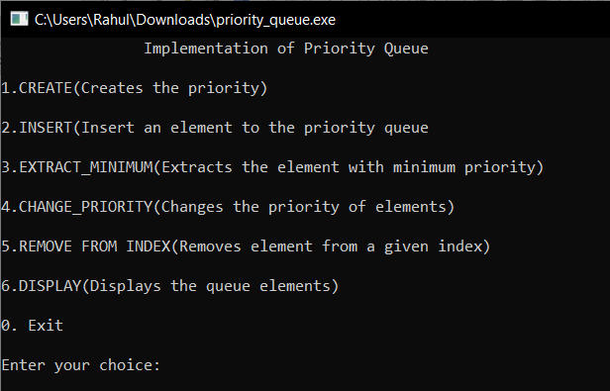

***First we create a minpriority queue containing 4 elements***

Let 1,2,3,4 are the values that are to be added into the queue

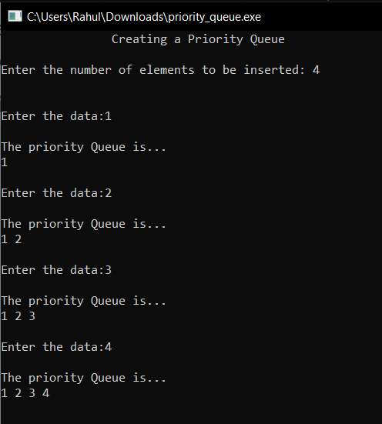

***Inserting another element in the priority queue***

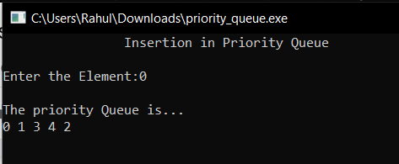

Since, 0 is the smallest of all existing values so according to the min priority rule, the element is placed at the front of the queue.

***Extracting the element with minimum priority***

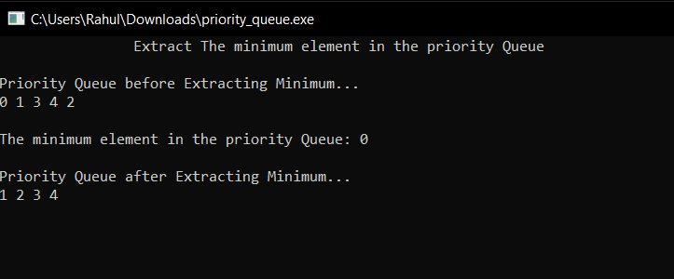

***The user can also change the priority at a given index, so the new input becomes the minimum priority***

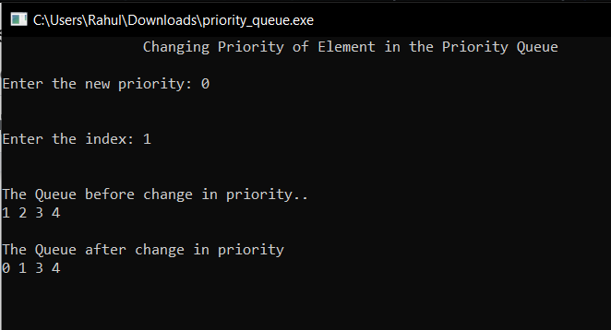

***The user can also delete the element from the specified index which is according to the priority***

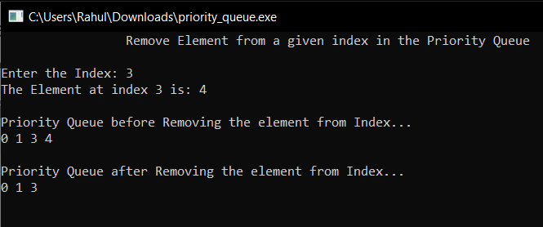

***Atlast, display the updated queue***

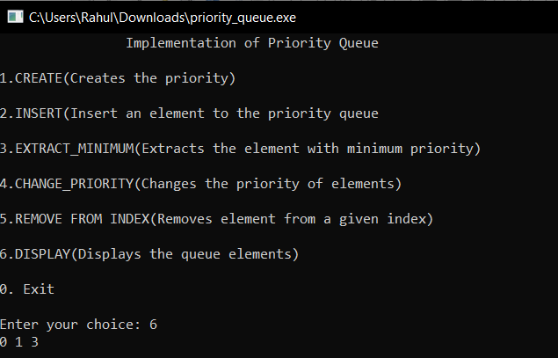

**Extreme cases**

**Underflow Detection:**

If we keep on removing elements from the priority queue a point will come when there is no elements to delete, the condition is the under flow condition which is properly demonstrated in my program as follows:

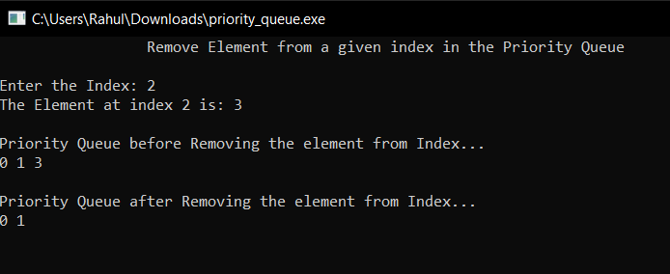

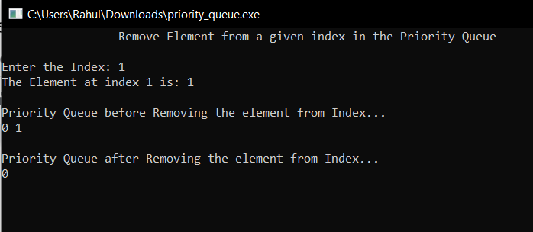

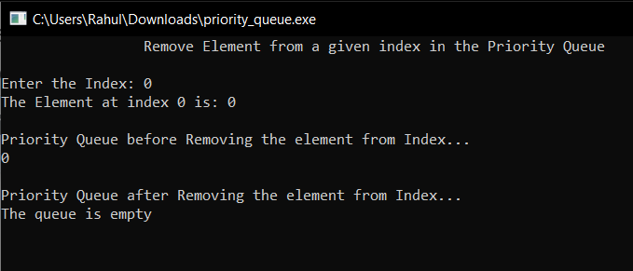

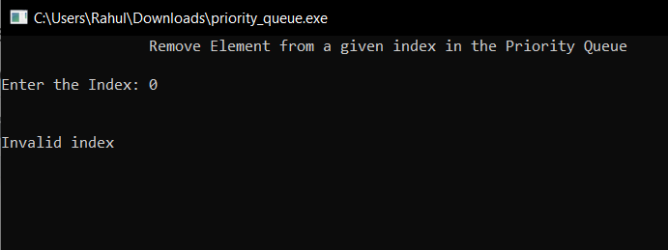

Also, if user tries to access the index outside the range of priority queue, same response is obtained

